[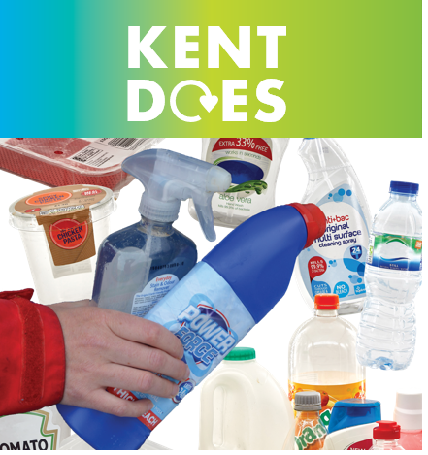](https://www.pledge2recycle.co.uk/kent)**KENT RECYCLES – DO YOU?**

Are you confused about what plastics you can recycle?

Pledge2Recycle Plastics are working with all Kent Councils to help reduce that confusion.

The charity, which works to educate and advise citizens has set up a dedicated website for Kent [www.pledge2recycle.co.uk/kent] which includes competitions for communities and general recycling guidance.

Did you know you can recycle ALL bottles whether from the bathroom and kitchen as well as plastic packaging in the form of a pot, tub or tray?

All bottles should be empty when placed for recycling with the tops back on. Pots, tubs and trays should have the absorbent layer and film lid removed as these need to go into general waste.

Please DO NOT PUT toothpaste tubes, pill packs, nappies, textiles, coffee pods, batteries and food into recycling. Textiles should go to specific banks either at community/retail/or Household Waste Centres. You can take carrier bags, bread bags and empty frozen veg packets, to your local supermarket front of store collection please check at [www.recyclenow.com/local-recycling](http://www.recyclenow.com/local-recycling). Sainsbury’s superstores now take ALL flexible packaging in front of store collections – guidance and a list of participating stores can be found at [www.about.sainsburys.co.uk/sustainability/plan-for-better/our-stories/2021/flexible-plastics](http://www.about.sainsburys.co.uk/sustainability/plan-for-better/our-stories/2021/flexible-plastics).

It is important that ALL PLASTIC PLACED FOR RECYCLING is CLEAN, DRY AND LOOSE and NOT in any carrier or black bags.

The team at Pledge2Recycle Plastics are happy to take your queries you will find them @pledge2recycle or e-mail Amanda.bakewell@recoup.org.